Capstone Checkpoint 4.1: Tree-of-Thought Reasoning
Thesis Check: Choosing the Right Claims Before Testing Them
Mohit Sachdeva | Agentic AI Program | October 2026
1. Is ToT appropriate?
Yes, in one step only: when the Thesis Analyst turns the investor’s thesis into testable claims. Everywhere else, ToT would add cost without improving accuracy.
- Rule: explore alternatives only where (1) an early wrong choice is expensive, (2) no later step can catch it, and (3) candidates can be scored cheaply before committing.
- Claim decomposition is the only step that meets all three.
Step | ToT? | Why
Thesis Analyst: claim decomposition | Yes | Every later step inherits the claims; nothing sends them back
Filing Researcher, Financial Data Analyst | No | ReAct already adapts to each search result; a miss ends as “insufficient evidence”
Bull and Bear Advocates | No | Searching for the most persuasive argument rewards rhetoric, not truth
Fact-Checker | No | A number matches its source or it doesn’t
Supervisor and verdict rubric | No | The same filing must give the same verdict, at a bounded cost

2. Where ToT is used, and why a linear chain fails
- ToT runs inside the Thesis Analyst, after the investor enters a thesis and before they confirm the claims (Figure 1).
- It picks the best set of 3–5 testable claims.
- It runs once per thesis. Quarterly re-checks reuse the confirmed claims.
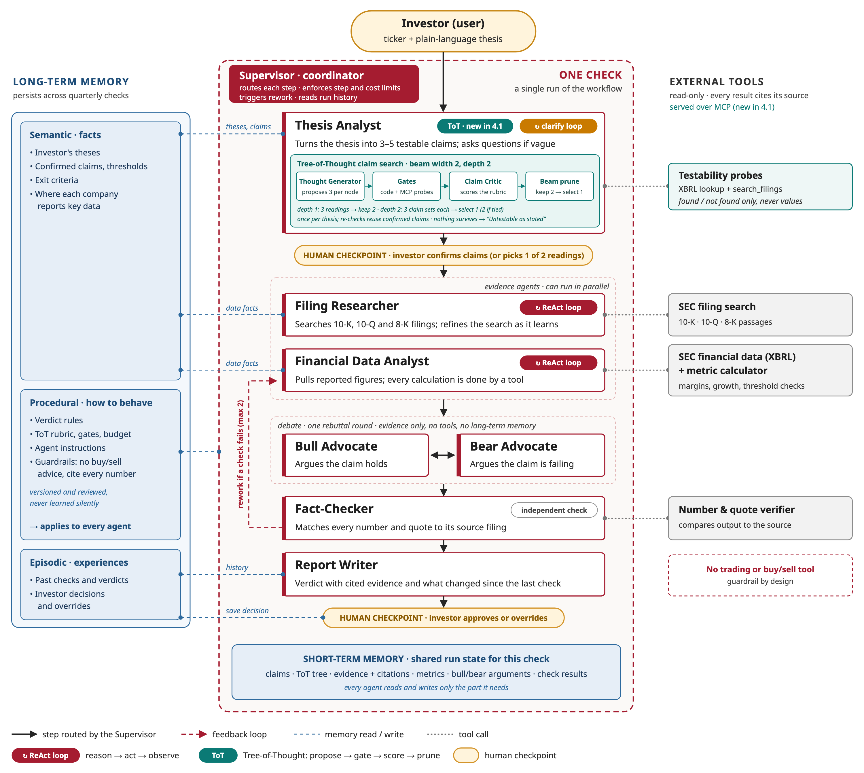
Figure 1. Thesis Check system design, with ToT claim search inside the Thesis Analyst.
Take Priya’s thesis: “AI demand will keep gross margins above 60%.” A linear chain of thought fails in three ways:
- Premature commitment. It fixes the meaning of “keep” in its first step. If it reads “keep” as last quarter’s margin, it never adds a claim on management’s outlook, so the claims can pass even after guidance drops below 60%. No later step catches this: the Fact-Checker checks evidence, not the choice of claims, and rework goes to the evidence agents. The investor confirming the claims is the person whose bias the product exists to counter.
- High branching. “AI demand,” “margins” and “keep” each have several valid meanings, giving roughly 30 combinations.
- Constraint complexity. A valid claim set must satisfy six rules at once, and a linear chain finds violations only after the research budget is spent:
  - 3–5 claims
  - each testable from this company’s SEC data
  - no price-based claims
  - the investor’s numbers unchanged
  - no duplicate measures
  - at least one claim that could fail
3. ToT structure
Element | Definition
Thought | One decision about making the thesis testable: how to read it, or how to measure it
Node (reasoning state) | The root plus the thoughts on its path, stored as an immutable record
Root | Thesis, ticker, clarifying answers, and the thresholds the investor stated
Depth 1 | A reading: the thesis as a cause-and-effect chain, e.g., AI demand → data-center sales → richer mix → gross margin ≥ 60%
Depth 2 (leaf) | A claim set: 3–5 claims, each with a metric, threshold, period and source
Branch | An alternative reading, or an alternative claim set for the same reading
Branching factor | 3 children per node; the beam keeps 2 readings, so at most 9 nodes
Depth limit | 2: a leaf is a complete claim set

Termination:
- The search stops when the depth-2 claim sets are scored. The top-scoring set goes to the investor for confirmation.
- It stops early if the budget runs out (it then shows the best set so far) or if no candidate survives (Section 5).
4. Search strategy: beam search, width 2
- Compares readings side by side and drops weak ones before spending calls on them.
- Has a fixed, predictable cost.
- Width 2 keeps a backup reading in case the critic misjudges the first.
- The generator proposes 3 distinct siblings in one call at temperature 0, so the same thesis gives nearly the same tree.
Strategy | Compute | Latency | Complexity | Verdict
Beam (chosen) | Fixed: 9 nodes, 12 LLM calls | 4 rounds, parallel within a level | Low: keep the top 2 per level | Best balance
BFS | 16 calls, grows with every reading | 4 rounds | Lowest | Expands readings already known to be weak
DFS | 6 to 16 calls, unpredictable | Up to 8 rounds | Medium: backtracking and a stop rule | Commits to the first reading: the failure ToT fixes
Monte Carlo | Dozens of rollouts | Many sequential rounds | High: rollouts and value backup | Built for deep trees; adds variance here

Budget:
- At most 14 LLM calls, 20 tool probes and about 30k tokens.
- Target latency is under 20 seconds.
- ToT stays only if it beats a single linear decomposition on the golden test set.
5. Evaluation and pruning
Who evaluates. The evaluator sits inside the Thesis Analyst and has two parts:
- Gates: code and tool checks.
- Claim Critic: a separate LLM prompt at temperature 0.
A deterministic decision maker then applies the thresholds below.
Gate | Check | Done by
Well-formed | Metric, threshold, period and source present | Pydantic schema
No price claims | No stock price, valuation multiple or price target | Rule check
Numbers kept | The investor’s thresholds appear unchanged | Code
Testable | The XBRL concept has values for the needed periods, or search_filings finds a passage for that period | Tool probes

- Probes return only “found” or “not found,” never values. Otherwise the search could pick claims whose result it already knows.
Criterion | Weight | Scores 5 when
Faithful | 30% | It tests the belief as stated, with the investor’s metric and time frame
Covers the chain | 25% | Every link from driver to outcome has a claim
Could fail | 25% | At least one claim could fail on the next filing (a check against bias)
Distinct | 10% | No two claims measure the same thing
Clear | 10% | The investor can confirm it in one read

- The critic scores each criterion from 1 to 5. Readings at depth 1 are scored on Faithful (60%) and Covers the chain (40%).
- It sees only the thesis and one candidate. It never sees the generator’s reasoning, the other candidates or the investor’s past edits.
Pruning:
- A claim that fails a gate is dropped.
- Depth 1: a reading is pruned if it is price-based or scores Faithful < 3. The top 2 survivors move on.
- Depth 2: a claim set is pruned if fewer than 3 claims remain, its outcome claim is lost, it scores Faithful < 3, or its total score is below 3.5.
- If nothing survives, the analyst asks one clarifying question and reruns once. If nothing survives again, the result is “Untestable as stated.”
- If the critic’s output is invalid twice, the system falls back to one linear decomposition through the same gates.
Ties (scores within 0.25):
- Different readings: the investor picks one of the two at the confirmation step.
- Same reading: a fixed order decides: more claims backed by XBRL data, then a higher “Could fail” score, then fewer claims.
6. ToT in action
(Illustrative; scores are hypothetical.)
- Linear chain: “gross margin above 60% last quarter; revenue growing; management positive on AI.” It misses guidance, and its third claim can’t fail. It says Intact even when guidance falls to 58%.
- ToT:
  - Keeps two readings: mix shift (4.6) and pricing power (4.4).
  - Prunes “guidance only” (3.0).
  - Drops an “AI accelerator revenue” claim, which isn’t reported, and a stock-price claim, which fails a gate.
- Selected set (4.55): data-center growth, gross margin ≥ 60% and next-quarter outlook ≥ 60%. The outlook claim comes back Broken.
7. Mapping ToT roles to tools
Role | LangChain / LangGraph | MCP | CrewAI (evaluated)
Thought Generator | Used. An LCEL chain with Pydantic output, run from a LangGraph node | Used. Reads confirmed claims and past edits from the thesis store | Could be an Agent; not needed
Critic / evaluator | Used. A separate LCEL chain for scores; gates as Python | Used. XBRL and search_filings probes, shared with the evidence agents | Could be an Agent; shared crew memory would break the critic’s isolation
Decision maker | Used. A LangGraph subgraph: generate → gate → score → prune, with budget counters and the confirmation interrupt | Not used | Not suitable: a manager LLM would choose the next step
State manager | Used. Immutable nodes in LangGraph state, with a SQLite checkpointer | Used. The thesis store keeps confirmed claims for re-checks | Not used: it would duplicate state

Why not CrewAI:
- Its strengths are delegation between agents and a manager LLM that routes work. Thesis Check’s fixed workflow rules out both.
- Role separation already comes from LangGraph nodes with separate prompts and scoped state.
- Revisit CrewAI if defining all eight agents in LangGraph proves clumsy.
8. Risk and mitigation
Risk: weak evaluation signals prune the best branch too early.
- Beam cuts are final.
- The critic infers what the investor meant from one sentence, and may prefer the most common or most fluent reading.
Mitigation: the critic ranks but rarely cuts, and is calibrated first.
- Only objective checks cut outright: the gates and clear misreadings (Faithful < 3).
- A beam width of 2 keeps a backup reading, and near-ties go to the investor.
- Before go-live, ToT is calibrated on about 20 golden theses: the reference reading must survive depth 1 at least 90% of the time.
- Every pruned branch is logged with its score and reason.
9. Project repository
Repository: https://github.com/mosachde/agentic-ai-real-world-capstone-work
This checkpoint: https://github.com/mosachde/agentic-ai-real-world-capstone-work/tree/checkpoint-4.1/docs

